**The Relationship between University Students’ Motivation and Learning Analytics Dashboard displaying Performance against Peers**

A. Kadekodi, C. Berkelaar, D. Kaminska, M. Lianto & N. Power

Murdoch University

**Abstract**

Learning Analytics (LA) is a dynamically developing field that has been studied for the past few years. Despite LA being the focus of much research, its development requires constant exploring to maximise its tremendous potential to support students and their learning processes. This paper reviews current research relevant to LA and emphasises that there is limited research into students’ perspective on LA. Therefore, this study focused on how students’ perceived motivation can be affected by using a ranking system in Learning Management System (LMS). The purpose of this survey was to explore whether students’ perceived motivation depends on their ranking position presented to them. An online survey was conducted and 77 participants took part of the survey.

The analysis demonstrated there was a dependency between students’ motivation and their ranking position displayed in LMS. Students with higher position in the class ranking were more motivated to study than those with a low position. Furthermore, the recommendations and the potential for the further research of LA from student’s perspective have been discussed in this report.

**Keywords -** Learning Analytics, Learning Management System, Dashboards, Motivation, Ranking

**Introduction**

In the past few years, there has been a rapid growth in adoption of Learning Analytics (LA) by academic institutions due to its success in utilising the available data to enhance teaching and learning. In learning activities, LA can be used to analyse the students’ learning patterns, their performance throughout the semester, and it is possible for the system to predict the students’ outcomes and students who are “at risk” through the analysis of big data. Through the analysis of the students’ learning patterns, teachers and institutions can make use of the data to improve the teaching activities such as trying to make students engage more in the class. There have been a lot of studies conducted on staff and institutions perspectives on LA. On the other hand, there have not been many studies looking at the students’ perspective on LA;  features they expect from LA and how their performance is affected by their motivation level. Therefore, this paper will investigate and discuss the relationship between students’ performance and their motivation level which will contribute to the improvements of LADs (Learning Analytics Dashboards) and students’ success rates.

**Literature Review**

Learning analytics can be defined as the “measurement, collection, analysis and reporting of data about learners and their contexts, for purposes of understanding and optimising learning and the environments in which it occurs” [1]. This learning data is gathered while the learners are engaged in learning experience. Learning analytics dashboard (LAD) can be defined as an interactive, historical, personalized, and analytical monitoring display that reflects students’ learning patterns, status, performance, and interactions. LAD includes visual elements such as charts, graphs, indicators and alert mechanisms [5]. At present, there is limited research focused on how students perceive LA, its tools (such as LAD) and the effect that these system have on them [2]. Additionally, further research also needs to be conducted to demonstrate a link between students’ motivation to succeed in their studies upon seeing their performance matched against their peers, as this issue has not been thoroughly addressed in scientific literature [2]. Hence, this literature review explores the students’ perception of LA, LAD and the impact that these may have on their motivation, by combining, examining and discussing the research conducted by various researchers.

A survey conducted on university students by Pistill & Arnold [3], showed that 89% of the students reported a positive experience of LA.  However, a study by Corrin & Barba [16] showed that students believed their experience with the LMS would be improved if they were better trained in its usage. Reimers [11] also stressed this need for training, as he stated that LA requires competencies such as importance of self-directedness, critical reflection and analytical skills, and very few students possess these skills and therefore there is little faith that LA will lead to more independence of learners to control and manage their learning process . Hence, if LA should be applied in education, then students should be guided to more self-directedness and critical reflection [11]. This viewpoint is also confirmed by the study from Pistill and Arnold [3], with  a majority of the students having a positive response to the computer generated personal emails, as they felt it was more personalised. Additionally, 69% of students in the study by Brooks & Bischel were also highly interested in the LMS providing personalised support and information about progress towards their degree goals [4]. They desired to have real time feedback about their performance at the dashboard [4]. Hence, the LMS should be an adaptive learning tool with personalised quizzes or practice questions, aligned to their strengths or weaknesses [4].

*Dashboards and Learning Analytics*

LADs are designed in order for students to view their learning patterns, thereby helping the students to modify their learning strategies and motivate their learning. The ultimate goal of LADs then, is to motivate students’ learning and, consequently improve their retention and performance outcomes. This is achieved by supporting awareness, self-reflection, and sense-making [6]. LADs provide a visual interface of the students’ own activity and their performance in comparison with peers [7].  This is the ‘one size fits all’ display and makes use of a leaderboard design and ranks students by performance, providing them with a way to directly compare themselves with their classmates [7]. Dominguez et al. [8] implemented a gamification plug-in for the blackboard LMS, and found that students did not enjoy the leaderboard competitive elements. This is because the students did not find it fun to compete with their classmates. Additionally, research conducted by Fox & Christy [9] has shown that the use of leaderboards can have unanticipated consequences such as reduced motivation from stereotype threat, and detrimental upward social comparison, that negatively influences academic performance [9]. The research concluded that a combination of leaderboards, badges and competition, did not improve education outcomes and, in the worst case scenario, can harm motivation, empowerment and satisfaction [9]. The above results are in contrast to the studies conducted by Fritz [10] that used ‘The Check My Activity’ (CMA) tool, allowing students to compare their LMS activity and grads against their peers. The study showed that students checked their grade book far more than any other function. This is further supported by the study conducted by Reimers and Neovesky [11], which showed that there was no clear opinion about whether notification from learning activities would be motivating (18% totally agreed and 15% total disagreed). Additionally, many students n the study also disagreed (44%) with the statement “I would like to compare my performance with my fellow students.” In addition, Aguilar [12] in his study provided performance dashboards to the students at risk, with the results showing that that these students were sensitive to comparative information in a negative manner. But the students indicated that they would it seek out if it was offered in a LMS. Furthermore, in support of this study, Teasley [7] examined how the students’ reaction is affected by prior academic performance. The study looked at whether the content of the feedback, in line with students’ overall grade point average (GPA) affected students’ responses to the dashboard [7]. The results showed that most students found the dashboard visual aspect informative, but there were differences between students’ interpretation of information provided and their potential use of the dashboard.  Students receiving feedback consistent with their grades (excellent feedback for high GPA students or poor feedback for low GPA students) found the dashboard visual aspects to be more helpful for making decisions about how to obtain the grades they wanted, than did the students receiving feedback inconsistent with their grades (excellent feedback for low GPA students or poor feedback for high GPA students) [7].

Implementations of certain features into the LAD have also been shown to increase students’ motivation. A questionnaire conducted by Atif et al. [13], indicated that “90% of students are interested in receiving alerts if their performance drops, 67% if they miss work, 52% if their participation decreased and 65% if they are identified as struggling” [14].  However, the study conducted by Roberts et al. [15] on four university focus groups, showed that this interest in the LAD is moderated by a belief that all students must be provided with the same learning opportunities. Additionally, students were also divided as to whether comparative results with other students should also be provided and if it is provided, then this data should be anonymous [15]. This also highlights the importance of  privacy concerns when designing the dashboards [15]. The students also preferred automated alerts rather than personalised messages from the teaching staff, due to the feelings of being under constant surveillance from the staff members [15]. Finally, the results also indicated that the students preferred to customise their own dashboard, to only include information that they perceived was useful to them. Thus, the above findings indicate that students desire some control over their Learning analytics. They want to control what they see on the dashboard; what appears on the dashboard; what others can see and how information is communicated [15]. But the level of control over Learning analytics the students would require is unknown [15]. Thus from above, it can be seen that further research is required to examine whether providing students with some control over their Learning analytics has any positive learning benefits and academic outcomes.

A study by Corrin & Barba also addressed the topic of LAD. Their study involved the use of a multi-phase mixed methods design to incorporate survey and interview methods. Participants were recruited from a first year biology subject, an environmental subject and a Japanese subject [16]. At the beginning of the semester, participants completed a survey to indicate their motivations about the subject and their personal learning goal. They then took part in an interview during which a dashboard was presented, consisting of their engagement and performance data  [16]. The participants were then asked to communicate about their interpretation of this feedback and the action they would take in response. Five themes were identified from the interviews. The first theme was that the participants’ learning reflection was impacted by the dashboard; the second theme looked at the students’ ability to plan new study strategies for the subject; the third theme looked at how participants’ motivation was affected by dashboard; the fourth theme looked whether class average should be included for assessments, online quizzes and LMS access and the fifth theme looked at benefits of placing all the assessment and online activities in one view. The results of the study stated majority of the students were able to interpret data in a way that allowed them to reflect on their performance and engagement and as a result the dashboard had a positive impact [16]. Several participants indicated increased use of LMS due to the increased motivation from seeing the dashboard feedback [16]. However some students reported that their subjects’ goal was not clear due to the comparison with their peers. [16]. The students also preferred a visual representation of their marks in the form of graphs [16].

*Student Performance Comparison using Dashboard*

Teasley [7] recommends not designing a “one size fits all” feedback display where students’ see the same feedback and are assessed by a single method. Dashboards should be designed to provide a personalised display of the user’s data, from extensive research conducted on the internal and external factors affecting their motivation. It is showed that students’ comparisons with others who perform worse, have led to feelings of superiority and positive effect [17] and vice versa, comparisons with others who perform better can lead to negative effects [18]. Hence, underperforming students could be provided with a personalised dashboard that provides them information about how to improve their grades. Lastly, more research needs to be conducted on examining the effect of feedback on student learning [7]. This is because intrapersonal (motivation, goal orientation) and external (context, timing and feedback) factors are poorly understood [7].

In conclusion, the literature suggests there is limited research regarding the impact on students’ motivation from the usage of dashboards display their performance relative to that of their peer. Some of research discussed above, have shown that students would not like to compare their performance with their peers, whilst others have indicated that this comparison is acceptable as long as the data is anonymous. Additionally, a divided opinion is also present with regards to the usefulness of the dashboard with regards to the students’ learning outcomes. Some studies have concluded that dashboards displaying student performance, did not improve educational outcomes and could possibility lead to harming motivation, empowerment and satisfaction.  On the other hand, other studies have shown that a majority of the students were able to interpret the data on the dashboard in a way that allowed them to reflect on their performance and engagement. Therefore, it can be concluded that there are gaps in the strategies for the effective implementation of Learning analytics tools due to a lack of understanding with regards to the student usage of Learning analytics. When the students’ needs are met, Learning analytics may support students’ motivation to strive successfully along their study journey.

**Research Problem and Aims**

Student success in university level education is essential for personal development and societal improvement. Therefore, it is important the education providers to implement systems that motivate a student to succeed in their studies.

Currently the use of eLearning inside educational institutions has aided in students’ performance, flexibility, access to information and convenience. This can be seen in the various current implementations of Learning analytics dashboards (LADs) inside many established institutes. The use of LADs are integral components to a student’s success; education services are aware of this and various research articles have been produced to gain a further understanding of Learning analytics (LA) tools and dashboards.

Based on the literature review it can be concluded that the student perception of Learning analytics is widely under-researched. Understanding a student’s perception towards Learning Analytics is paramount for creating LADs which benefit a student’s performance. At present there are very limited studies that focus on the relationship between students' motivation to succeed in their studies upon viewing the comparison of their performance against their peers.

In this research, the primary objective is to explore and identify what students expect from Learning analytics to assist them with succeeding in their studies. Specifically, it will address:

*How students perceive their motivation to succeed in their studies will be affected by the use of dashboards to display their performance relative to other students.*

To answer the above question, this project will investigate students’ opinion on enabling others to see their performance within the same unit. Additionally, this project will also investigate the relation between the student’s motivation and the information being presented to them about their performance. This will allow for better creation of LADs, ultimately leading to higher performance rates for the students.

**Research Method**

*Participants*

85 students were invited to partake in this study. All the students were currently studying a course in Murdoch University at Perth, Western Australia. Due to their university experience, all the students invited to complete the survey, had interacted with a LMS at some point in their studies. Initially, students were contacted through social networks, such as through friendship groups and social media. However, to ensure that the adequate quota of responses were met, students enrolled in units similar to those of group members were invited to complete the survey. From the 85 students invited to complete this survey, 77 successfully part-took in this study. 7 responses were removed due to incompleteness.

*Materials*

Students completed an anonymous survey online via SurveyMonkey within their own time. The survey had two main parts: Participant information and LMS dashboard. The survey asked participants for some personal information regarding their demographic and experiences as an university student. The students were then shown some possible scenarios that could be implemented on their LMS dashboards, and were questioned on their feelings towards them and how it could impact their future studies.

*Procedure*

After the completion and finalisation of the survey design, a pilot run was completed by initially distributing them to a small group of 8 Murdoch students for testing. This sample group provided constructive feedback and suggestions for the survey, to ensure that the respondents were aware of the topic and how their contribution can assist the research. Small changes were suggested such as the rephrasing of Q6 and Q11 to give the respondent a clearer idea of what was being asked of them. These suggestions were incorporated into the final version of the survey, which was then issued to students across a week-long period. The second and third questions in the survey asked for personal information from the students to provide an idea of the demographic being associated with the findings, however this information limited only to the extent of respondent’s gender and age bracket. After completing the first portion of this survey, the students were then faced with questions relating to their student experience at Murdoch. Respondents were then asked several general questions about their university experience, such as average grade and field of study, which allowed for some diversity in findings through particular areas of the university.

After students had completed the personal information aspects of this survey, they were provided with the potential additions to LMS. These additions included two forms of ranking systems, one by text in the current assessment screen and the other through a horizontal bar graph (Figure 1-4 below).

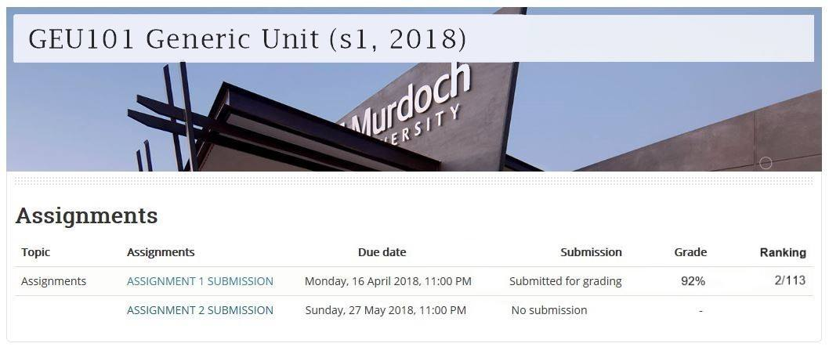

*Figure 1. LMS high assessment ranking system*

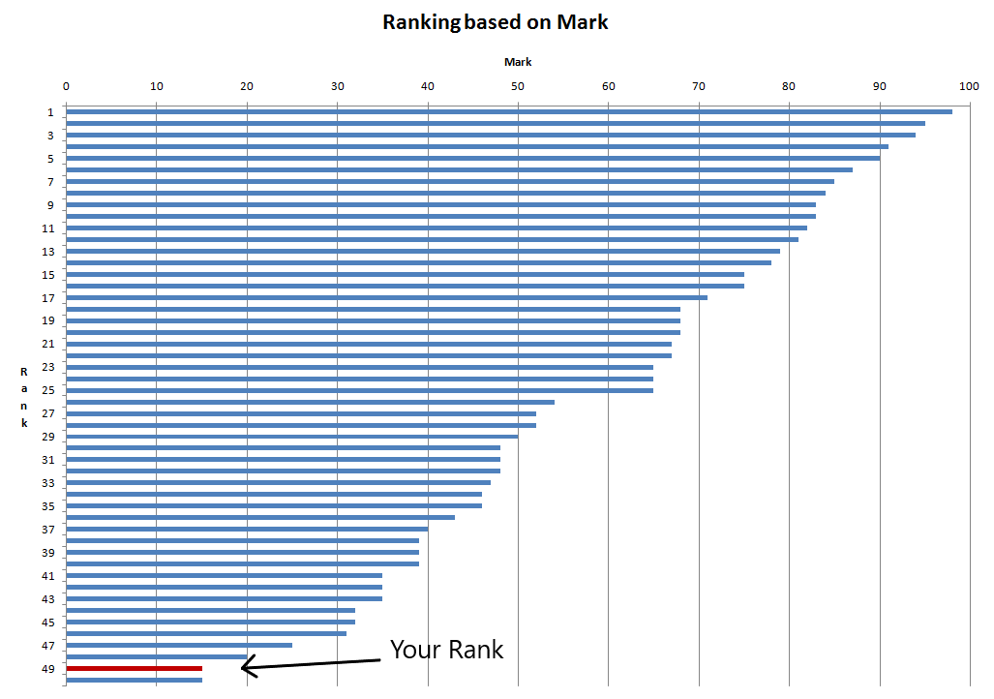

*Figure 2. LMS low semester ranking system*

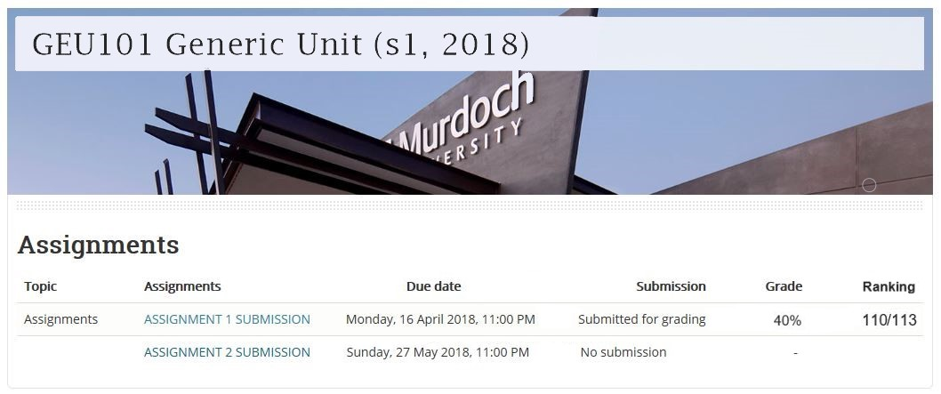

*Figure 3. LMS low assessment ranking system*

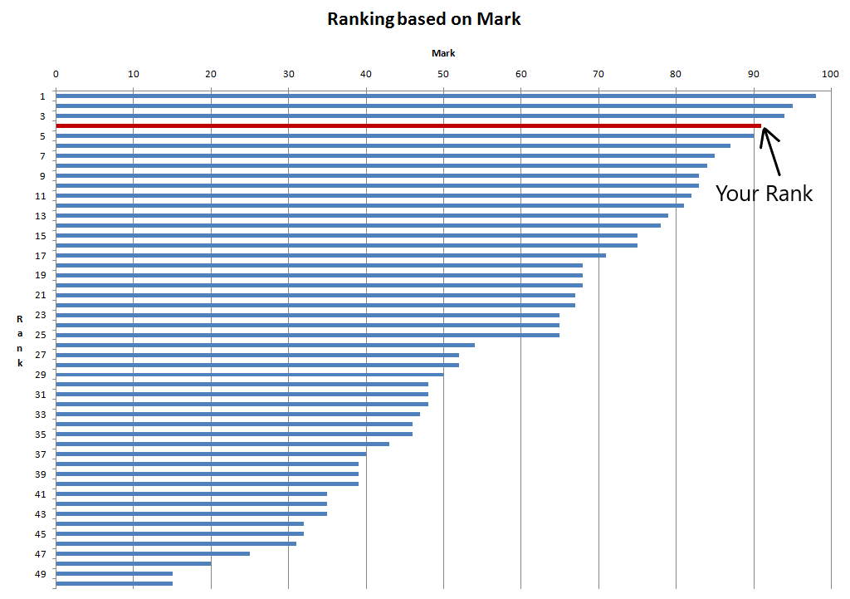

*Figure 4. LMS high semester ranking system*

Respondents for this survey were split into two groups, Group A and Group B. Respondents were assigned to each group based on the order in which they accessed the survey - alternate manner (1st A, 2nd B, 3rd A etc.). One group of respondents (50% of participants) were faced with an image showing them performing as one of the highest in their unit (Figure 1), whereas the remaining respondents were shown them performing as one of the worst compared to their peers (Figure 2). By showing respondents a modified version of their LMS dashboard, we created a familiar environment to ensure their responses accurately reflected their motivation levels. From these visualisations, students were asked how their motivation for the remainder of the semester would be impacted, if the above relevant scenario was incorporated to their LMS dashboard. Student responses from these visualisations were then recorded and analysed to investigate how students’ motivation would be impacted by the introduction of a ranking system to their LMS dashboard.

Once an adequate number of responses were collected, analysis was conducted to check for a dependency between student’s displayed performance and their level of motivation. For this purpose two tailed t-tests were performed, using rank as the independent variable and perceived motivation as the dependent one. These tests checked the relation between rank and motivation to assess whether the difference in visualisation had an impact on their motivation levels. The first test used Figure 1 and 3, to assess for the motivation for assignment 2. The second test used Figure 2 and 4 to assess for the motivation for the rest of the semester.  The data from this analysis was then used to come to a conclusion on the introduction of a ranking system to LMS, and how this could impact student motivation.

**Results**

*Students’ Reaction to Ranking System*

Based on the data collected from students’ survey, it was found that 57% of 70 students would like to have a ranking system as a part of their dashboard in LMS. Moreover, 68% of the participants prefered to see ranking for both individual assessment and their overall performance. Furthermore, 85% of the respondents would like their ranking position to be presented only to themselves rather than displaying it to the cohort as a whole. Students who generally had better grades were more willing for their results to be seen by other students. However, the difference between high and low grade students were not statistically significant and this could be attributed to small sample of responses from students. Of the 70 respondents, there were only 11 students who were willing to let their peers view their ranking.

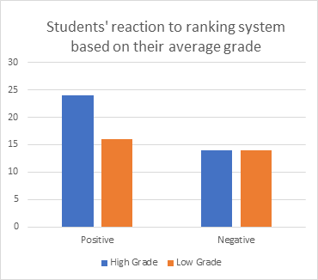

*Chart 1. Students reaction to ranking system based on their average grade*

Survey participants were also asked about their average grade. The number of students with high grade and low grade and their reaction to the ranking system is shown in Chart 1. Although students with high-grades showed a slightly more positive reaction towards the ranking system feature, than students who had low grades, this difference was not statistically significant X2(1, N=68)=0.688, p=0.414).

*Ranking System and Students’ Motivation*

Two tailed t-tests have also been performed to test the hypothesis, which states that students’ motivation level depends on their position in the class ranking presented to them. The independent variable in this case is their ranking position and the dependent variable is their perceived motivation. When the students’ ranking position is high their motivation increases, and when the position is low their motivation diminishes.

|  |  |  |  |  |  |  |  |
| --- | --- | --- | --- | --- | --- | --- | --- |
| ***Measure*** | ***Ranking Position*** | ***M*** | ***SD*** | ***N*** | ***t*** | ***df*** | ***p*** |
| ***Motivation for assignment 2*** | High | 4.08 | 0.92 | 35 | 2.02 | 65 | 0.48 |
| Low | 3.59 | 1.07 | 32 |
| ***Motivation for the rest of the semester*** | High | 3.91 | 0.92 | 35 | 3.51 | 56.75 | 0.001 |
| Low | 2.93 | 1.32 | 33 |

*Table 1. The motivation for future assignment and rest of the semester based on the presented position in the ranking.*

Two Independent sample t-tests were used to determine whether students’ ranking position had an influence on their motivation level (Table 1). Seventy participants were selected for these tests and were divided into two groups. However, three students did not participate in the first test and two did not participate in the second test. Thirty five students in the first group were presented with a picture that showed them having a high ranking position and thirty two students in the second group were presented with an image that showed them having a low ranking position against their peers. In the first test, participants were shown the ranking of their first assignment presented in Murdoch LMS site as shown in Figure 1 and Figure 3. The ranking was displayed in a numeric manner i.e. 2/113. The results found that there was no significant difference in motivation level towards completing the second assignment between the two groups (4.08 versus 3.59, t(65)=2.02, p=0.48).In the second test, participants were presented with a ranking visualisation of their score in the second assignment compared to their peers. In this test, thirty five students in the first group were presented with a visualisation that showed them having a high ranking compared to their peers. Thirty three students in the second group were presented with a low ranking compared to their peers. The ranking was displayed as a graph as shown in Figure 2 and Figure 4. The findings concluded that there was a significant difference in motivation level for the rest of the semester between students who were given higher ranking visualisation (M=3.91, SD=0.92) and students who were given lower ranking visualisation (M=2.93, SD=1.32), t(56.75)=3.51, p=0.001). Therefore, it is seen that the initial hypothesis regarding the relationship between the students’ perceived motivation and their ranking position has only been confirmed by the second test. However, it was not supported by the first test as there was no significant difference in motivation levels. This can mainly be attributed to a small sample size which increases the margin of error.

**Discussion**

Learning management system (LMS) is a key component of a student’s university experience, as it changes the way students access and engage with their course material. The purpose of this study was to research the impact a ranking system would have on university students if it was implemented into their LMS. A key factor of this was the effect a ranking system would have on student’s motivation for the rest of the semester based on their displayed position in comparison to their peers within the cohort.

The findings associated to our primary research question “*How students perceive their motivation to succeed in their studies will be affected by the use of dashboards to display their performance relative to other students.”* strongly suggest a relationship between a students’ motivation and their rank in the class. The results shown in Table 1 show a strong relation between low ranked students feeling demotivated and highly ranked students feeling motivated to consistently perform to the same level. This is primarily due to students of lower ranking having reduced motivation in improving their performance after they received their poor results. Students shown performing towards the lower end of the class could be strongly impacted by this dashboard visualisation, as student ranking may become a competition with their fellow students and can lead to negative effects [18]. In contrast to this, students at the other end of the ranking system are encouraged to continue performing at a high standard to maintain, or even improve their ranking within the class. By displaying this high rank, a student is given concrete validation that the effort they are putting towards their studies is viable, as they have performed better than a large majority of their fellow students. In fact, studies show that students who are performing well compared to their cohort feel a sense of superiority and positivity, and this competitive edge can be a strong factor in motivating students to continue performing well [17]. As discussed earlier, LA can be a powerful tool when it comes to the improvement and optimisation of student learning. The findings above give a strong platform for LA to operate on, as academics can utilise this ranking system to better allocate resources to students struggling to perform.

These results also provide the powerful evidence to enable the creation of better LADs, allowing all students regardless of their rank to be motivated in succeeding at their studies. As previously reported by Brooks and Bichsel [4], dashboards need to provide personalized support . The LADs should be created to align with the strengths and weaknesses of each student [7]. High performing students who are ranked high in the class should be shown their ranks. This leads to those students who are performing well in the class to be motivated to keep performing well through feelings of superiority and pride. The lower performing students should not be shown their low ranking position against their peers. As shown by our results, this will lead to a negative effect. Instead of motivating a student to do better it will lead to strong demotivation. In support of this, Fritz [10] states that a ‘one size fits all’ style LAD is a defective LAD design, since aspects like ranking can have negative effects on the individual. Hence, from the research conducted it has been shown that a successful LAD is an adaptive LAD. This involves, adapting it to suit the student using it and providing only the information that is beneficial to the student. Brooks & Bischel support this statement, by stating that 69% of the students in their study were highly interested in the LMS providing personalised support and information about progress towards their degree goals [4].

There are two suggestions of implementing this adaptive LAD design. First one involves designing a static LAD that allows high ranked students to see their performance against their peers. The lower ranked students will not be provided a ranking against their peers, but they will be provided a personalised dashboard/information about their performance in the assessment and valuable tips on improvement so that they can reach their academic goals. This will lead to increased motivation for both higher and lower ranked students.  This design enforces the result of the study conducted by Festinger [20], which showed that social comparison has positive affect to an individual who is performing better than his peers [20]. The second design is a LAD that provides customizable options for the student to design their LAD. This will allow students who desire specific modules, such as seeing their ranking against their peers to add it to their own dashboard. Providing a truly personalized LAD allows the students to take control of their own learning experience [19]. The design and analysis of these recommended dashboards design are  the areas for future research in Learning analytics.

Providing a dashboard that is customizable by the student, will lead to the creation of dashboards that will have a positive effect on the students’ learning journey and motivate them to succeed in their studies. Additionally, the findings of the survey will also provide an opportunity for future potentially noteworthy results to be inferred from a similar survey. Due to the small sample of respondent participation, analysis regarding demographics such as gender and overall performance lacked significant detail.

Therefore it can be concluded that further research in LA is required to expand upon the knowledge about the relationship between students’ LAD tools, their perception and academic success. Additional studies should also gather a large sample of participants to determine if the hypotheses presented in this paper is valid, which can be useful in extrapolation of the data regarding the students’ expectations to LMS and their reaction to ranking systems.

**Appendices**

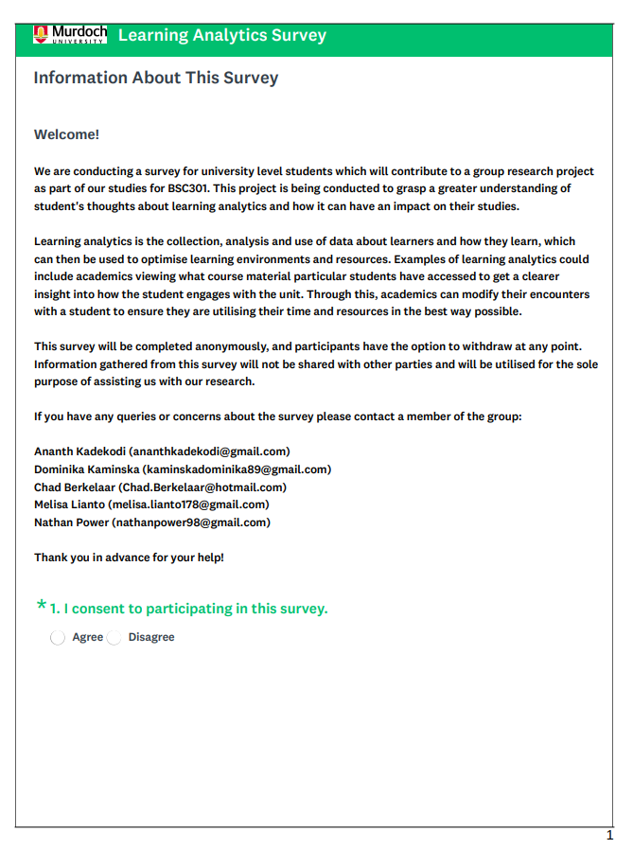

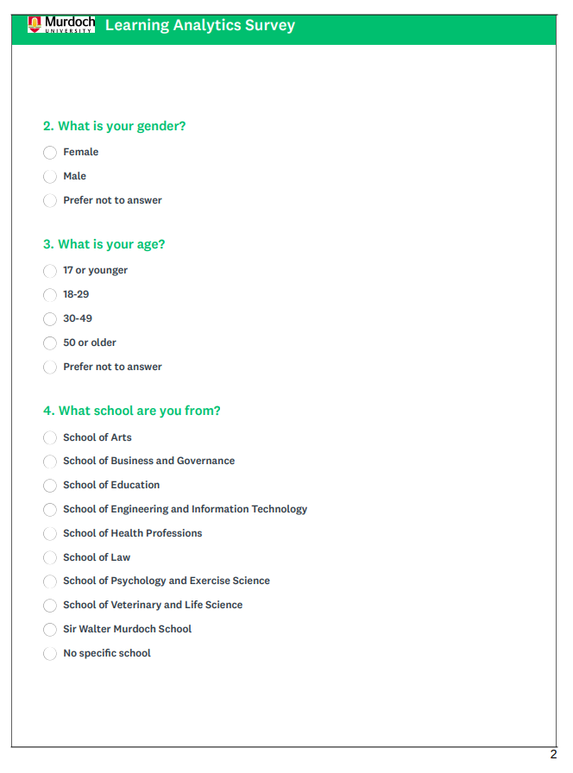

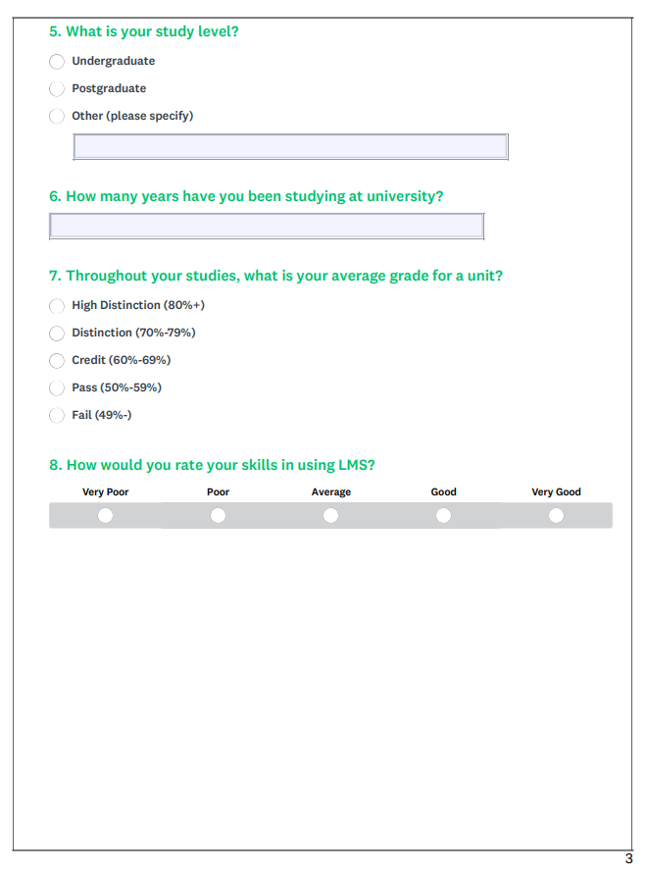

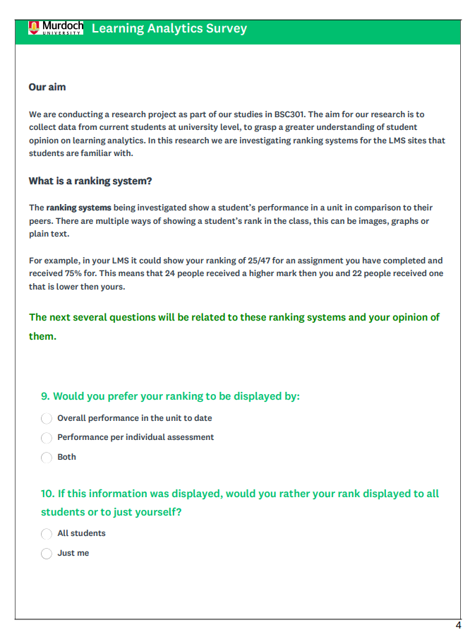

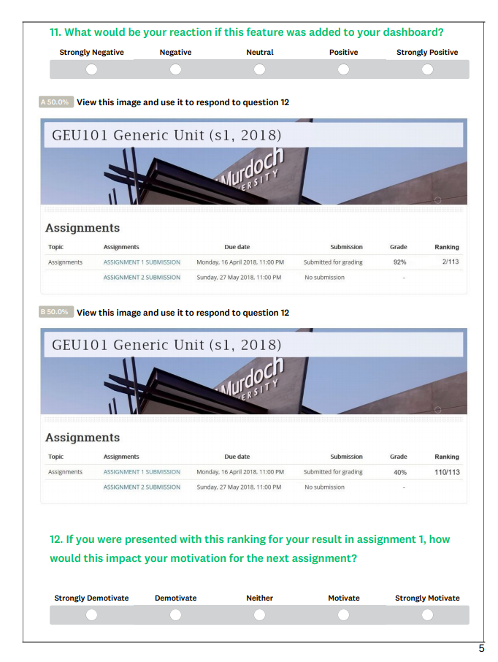

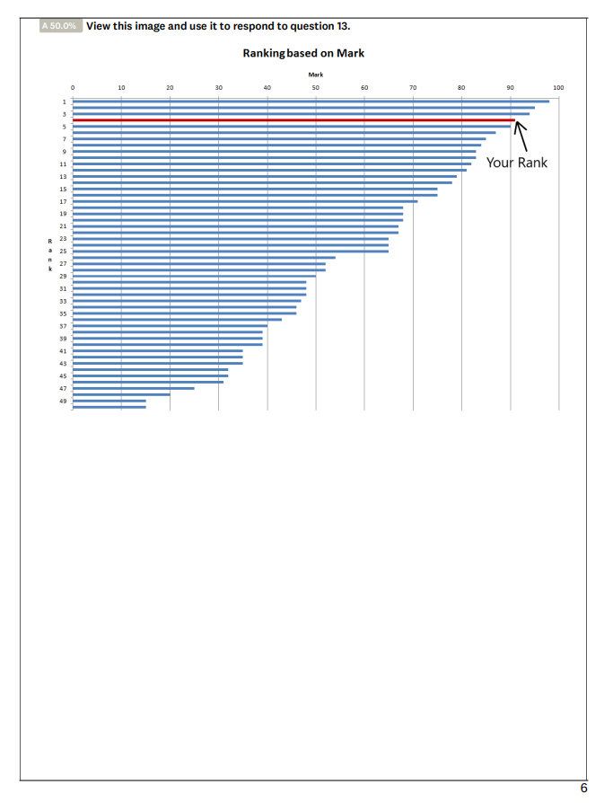

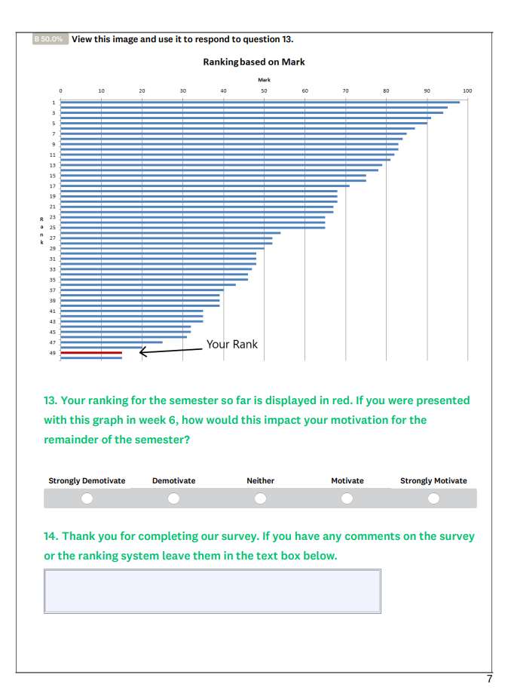

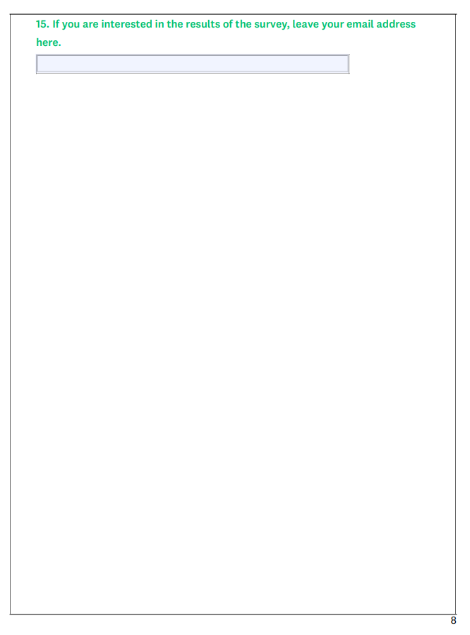

**References**

[1]    Conference Chair-Long, P., Conference Chair-Siemens, G., Program Chair-Conole, G. and Chair-Ga&#353 (2011). *Proceedings of the 1st International Conference on Learning Analytics and Knowledge*. [online] Dl.acm.org. Available at: https://dl.acm.org/citation.cfm?id=2090116.

[2]    R. Bodily and K. Verbert, "Trends and issues in student-facing learning analytics reporting systems research," in 2017, . DOI: 10.1145/3027385.3027403.

[3]    K. Arnold, and M. Pistill. (2012, April.). “Course signals at Purdue: Using Learning Analytics to Increase Student Success” Purdue University. [Online]. Available:         [https://www.researchgate.net/publication/254462830_Course_signals_at_Purdue_Using_l](https://www.researchgate.net/publication/254462830_Course_signals_at_Purdue_Us%09ng_l)earning_analytics_to_increase_student _success.

[4]    D. Brooks, and J. Bichsel. (2014, September.). “The Current Ecosystem of Learning Management Systems in Higher Education: Student, Faculty and IT Perspectives.” *Educause.* [Online]. Available: [https://library.educause.edu/resources/2014/9/the-current-ecosystem](https://library.educause.edu/resources/2014/9/the%09current-ecosystem) of-learning-management-systems-in-higher-education- student faculty-and-it-perspectives.

[5]    Podgorelec, Vili & Kuhar, Sasa. (2011). Taking Advantage of Education Data: Advanced Data Analysis and Reporting in Virtual Learning Environments*. Elektronika ir Elektrotechnika.* 114.  111-116. 10.5755/j01.eee.114.8.708.

[6]    Verbert, K., Duval, E., Klerkx, J., Govaerts, S., & Santos, J. L. (2013). Learning analytics dashboard applications. *American Behavioral Scientist*, 57(10), 1500–1509

[7]    Teasley, S.D (2017). *Tech Know Learn*. 22: 377.<https://doi.org/10.1007/s10758-017>   9314-3

[8]    Dominguez, A., Saenz-de-Navarrete, J., de-Marcos, L., Ferna´ndez-Sanz, L., Page´s, C., &  Martı´nez-Herra´iz, J.-J. (2013). Gamifying learning experiences: Practical implications and outcomes. *Computers in Education*, 63, 380–392.

[9]    Christy, K. R., & Fox, J. (2014). Leaderboards in a virtual classroom: A test of stereotype threat and social comparison explanations for women’s math performance. *Computers & Education*, 78, 66–77.

[10] Fritz, J. (2011). Classroom walls that talk: Using online course activity data of successful students to raise self- awareness of underperforming peers. *The Internet and  Higher Education*, 14(2), 89–97

[11] Reimers, G., & Neovesky, A. (2015). Student focused dashboards—An analysis of current student dashboards and what students really want. *In Proceedings of the 7th international   conference on computer supported education (CSEDU)* (pp. 399–404).

[12]     Aguilar, S. (2016). Perceived motivational affordances*: Capturing and measuring  students’ sense-making around visualizations of their academic achievement information.* (Doctoral Dissertation) University of Michigan, Ann Arbor, MI.

[13] Atif, A., Bilgin, A., & Richards, D. (2015). Student preferences and attitudes to the use of  early alerts. *In Paper presented at the twenty-first Americas conference on  information systems.*

[14] Heath, J., & Leinonen, E. (2016). An institution wide approach to learning analytics.  In C. A. M. Gavan (Ed.), *Developing effective educational experiences through  learning analytics* (pp. 73–87). Hershey, PA: IGI Global.

[15] Roberts, L.D., Howell, J.A. & Seaman, K (2017). Tech Know Learn. 22: 317. https://doi.org/10.1007/s10758

[16] L. Corrin, and P. De Barba. (2014). “Exploring students interpretation of feedback delivered through learning analytics dashboards.” *Rhetoric and Relality.* [Online]. Available: http://www.ijssst.info/info/IEEE-Citation-StyleGuide.pdf.

[17] Festinger, L. (1954). A theory of social comparison processes. *Human Relations*, 7(2), 117–140.

[18] Major, B., Testa, M., & Bylsma, W. H. (1991). Responses to upward and downward social comparisons: The impact of esteem- relevance and perceived control in social comparison. In J. Suls & T. A. Wills (Eds.), *Contemporary theory and research* (pp. 237–260). Hillsdale, NJ: Erlbaum.

[19] Roberts, L.D., Howell, J.A. & Seaman, K (2017). Tech Know Learn. 22: 317. https://doi.org/10.1007/s10758

[20]   Festinger, L. (1954). A theory of social comparison processes. *Human Relations*, 7(2), 117–140.